ASP.NET

Filling data in combo box without flicker / Page Re-Load (Asynchronously)

In ASP.Net allow us to get information from the server without refreshing the entire page. This can come in very handy when you have large, graphic intensive, pages or if server side validation is needed for a field before submitting the entire page.
Notice in my example how the model drop down list is repopulated every time the selected item in the Start With list is changed. The information for the State list is pulled from the server and the selected item in the State list is changed. The information for the District list is pulled from the server but notice how that list is the only item on the page to refresh. The rest of the page content is left in place that results in a much smoother user experience. It is also faster than refreshing the entire page as only the information for the list is sent back to the client instead of the entire page.

Steps:

- Post the All files into One Folder (Ex: D:\Async)
- Create Virtual Directory Named 'Asynchronous_Loading' for this Path (D:\Async)
- Open the Script file 'Execution Scripts.sql' from 'Script' Folder (Ex: D:\Async\Scripts) in SQL Query Analyzer.
- Just Press 'F5', Now One DataBase Created Named 'India' and Two Tables Created Named 'States','Districts'.

- In Many of our pages I have noted as an IP like '172.26.11.215'. (This is my Server IP which having the Source File)

- You can Change to your Server IP / Name. (Name of the System which has the Source File)

Run:
You can run the project in two ways 1. .NET IDE 2. Internet Explorer (Directly)

- .NET IDE :

- Double click the Solution from the path (D:\Async)
Ex :

- Now Press ‘F5’ to run.

- Now, You can eye the following Err Screen.
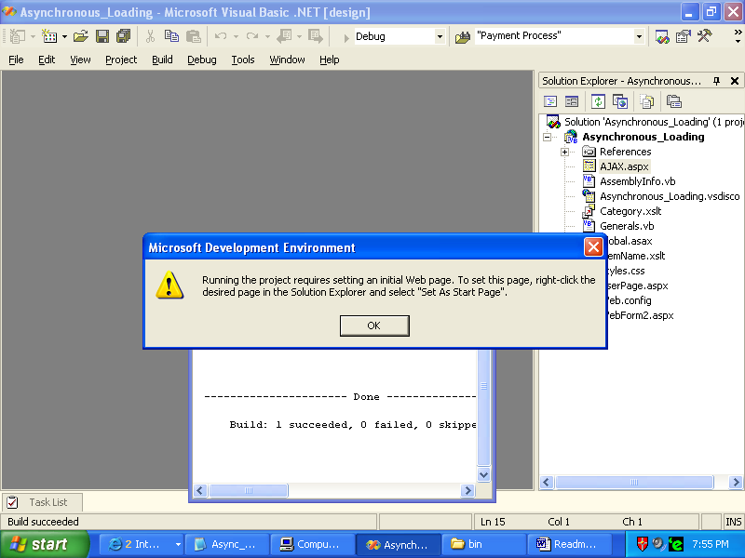

- Because, There is no any Page (.aspx) has been specified as ‘StartUp Page’.

To Set the Page as StartUp Page :
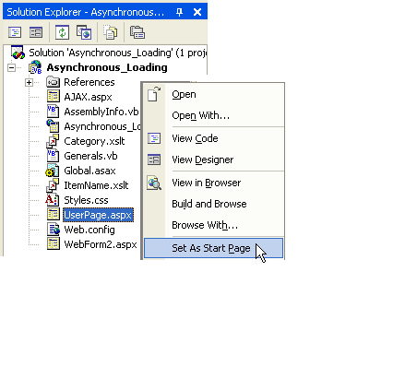
- Press Ctrl + Alt + L for Solution Explorer.
- In Solution Explorer Window.
- Place Mouse Pointer on UserPage.aspx.
- Press the Right Mouse Button.
- Select the Set As Start Page in Drop-Down
Menu.
- Now the Page set as StartUp Page.
- Now , You can Run the Project , Press F5
- Screen Looks like as follows.
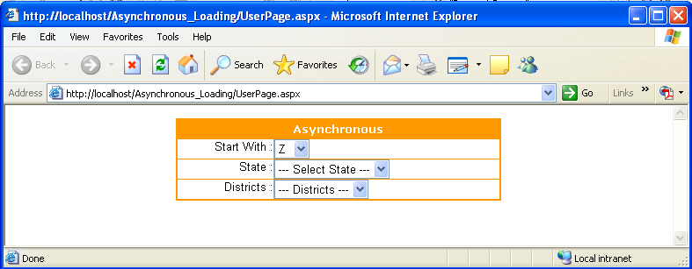

(or)

2. Internet Explorer (Directly)

- Open the Internet Explorer and Type the following URL as
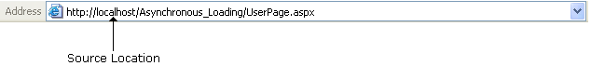

- Press Enter , The Screen appear.

1. Selete the Start With Combo
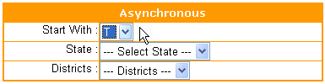

After Selected the Letter ‘T’ in Start With combo, All Stats are filled in Next ComboBox named State without any Screen flicker / freeze / Page Re-Load.

2. Select the Next Combo State as

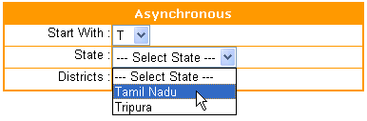

After Selected the Item Tamil Nadu in State combo, All Districts are filled in Next ComboBox named Districts without any Screen flicker / freeze / Page Re-Load. (30 Districts)
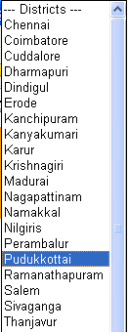

3. District Combo

Note:

1.If the source file have been placed in System1 , You try to call the page in another System System2 then the URL should be
Http://System2/Asynchronous_Loading/UserPage.aspx

Or

2.If the source file have been placed in System1 , You try to call the page in Same System System1 then the URL should be

Http://System1/Asynchronous_Loading/UserPage.aspx
(or)
Http://localhost/Asynchronous_Loading/UserPage.aspx

3. When You try to run the Project from the Internet Explorer Directly, If the following Err Screen shows.
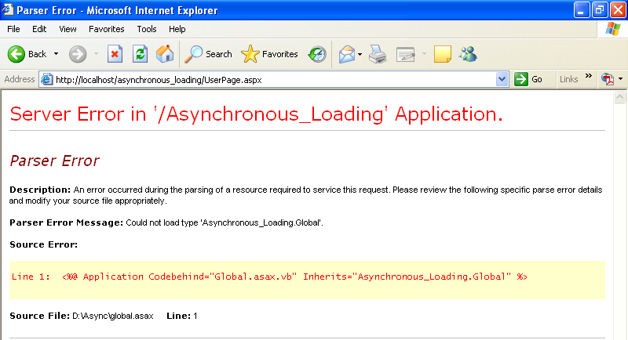

Because, There is no Asynchronous_Loading.dll file found in \Bin Folder

Solution:
- Double click the Solution from the path (D:\Async)
Ex :

- Now the Solution Open.
- Select the Build Menu and Select Build Solution.
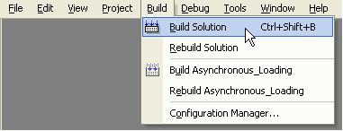

- Now Our Solution Built and Asynchronous_Loading.dll file placed in \Bin folder.
- Now You can Run the Project From the Internet Explorer Directly.
- You can retrieve the State, District Details from the Access Database. So , The Access Database also provided here (D:\Async\bin\India.mdb).
- Change Your Connection String and Namespace to work with Access Database.

Thanks

Pandian S
Dotnet_pandian@yahoo.co.in

